

Stack up

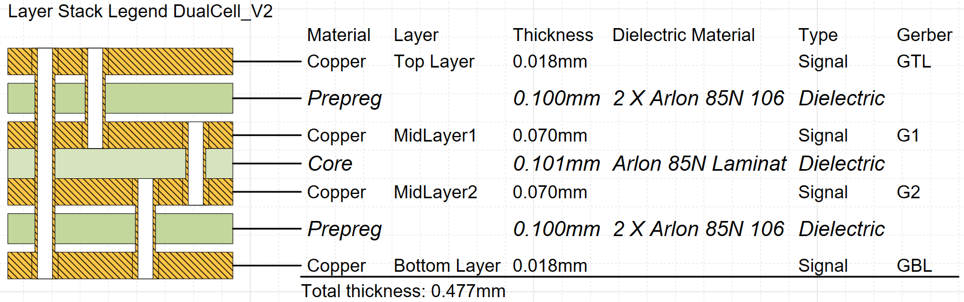

PCB drawing

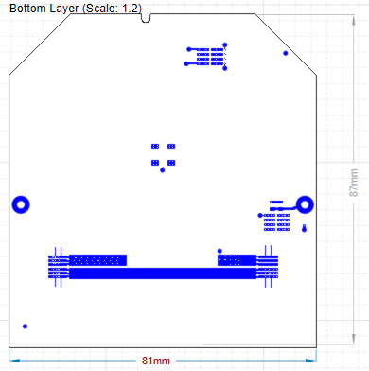 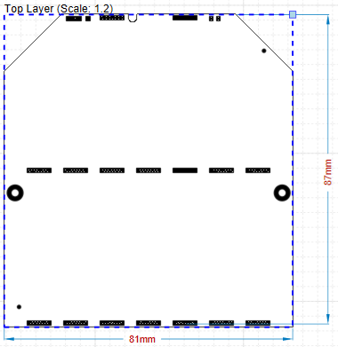

Filelist:

* Job description (this file)
* Gerber files
* NC Drill files
* ODB++ Files
* Cluster drawing